W4-S3 PRACTICE
CSS FLEXBOX WITH REAL CASES

 At the end of this practice, you should be able to…
- Apply a top to bottom approach to define your CSS strategy
- From mockups, write your CSS code
- From a customer need, define your mockup and your HTML/CSS code

 How to work?
- Download the start code from the LMS
- Open the folder in VS Code

How to submit?
- Push your final code on your GitHub repository
- Then attach the GitHub path to the MS Team assignment and turn it in

 Are you lost?
You can read the following documentation to be ready for this practice:
- Guide - WC3 School
- Guide - Flexbox properties
- Video – Flex in 10 minutes!

What is a top to bottom approach in designing CSS?
A Top-to-bottom approach in designing CSS is a method where you start styling from the most general elements and move towards the more specific elements.

This approach helps in dividing your layout tasks in smaller tasks!

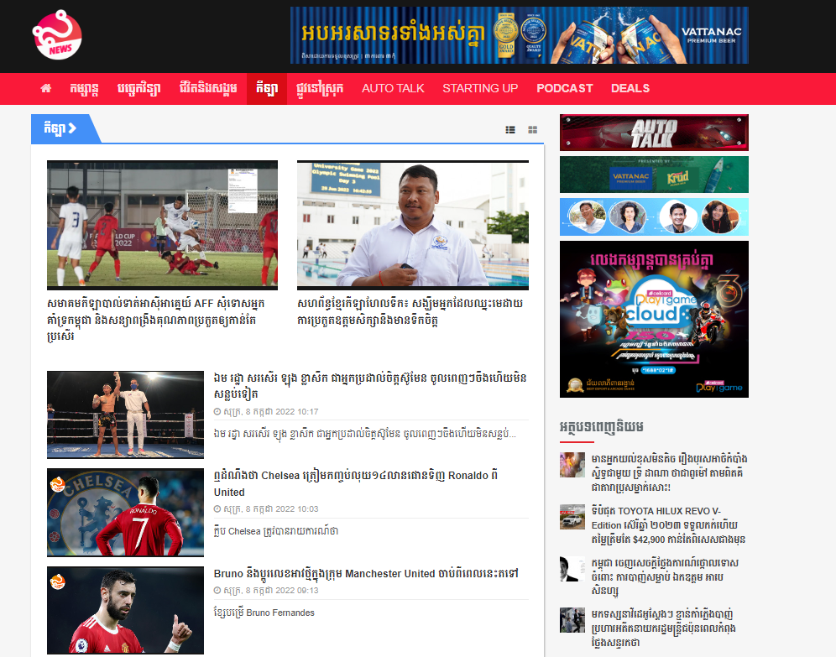
Our example

As example on the above page, we focus first on the main elements:
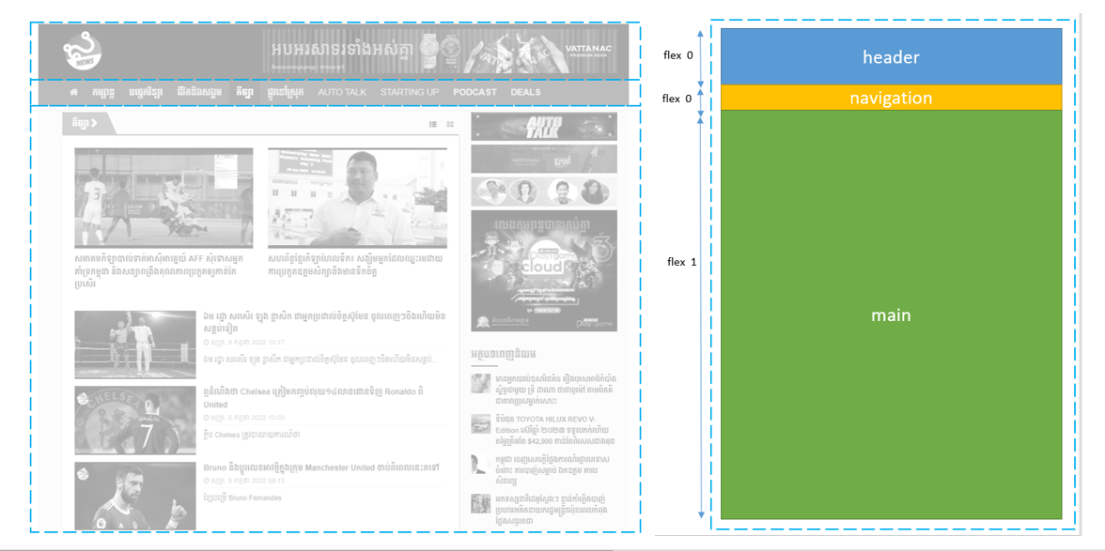

We then identify the sub containers:
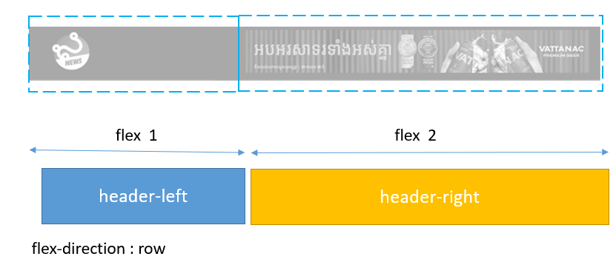

We also make sure to choose appropriate container names:
As example bellow, the main container is composed of the content and the sidebar containers
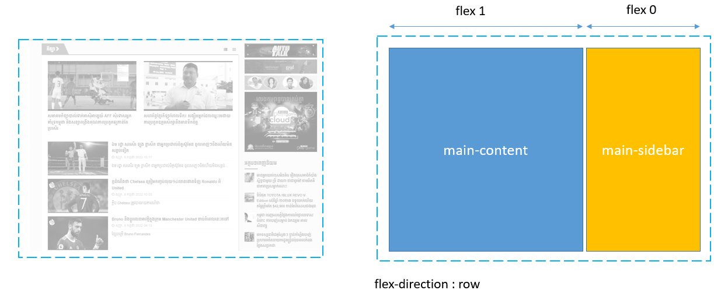

The content container itself if composed of 3 parts, as follows:
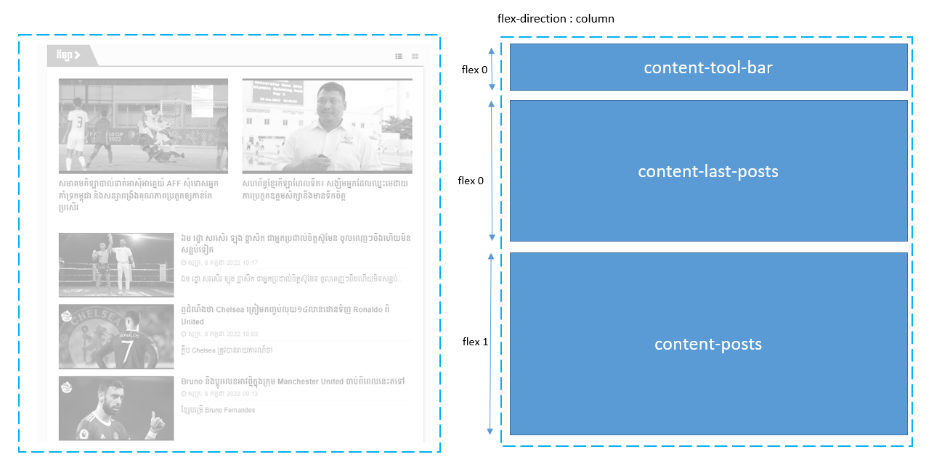

Finally, we define the deeper containers, such as the post item:
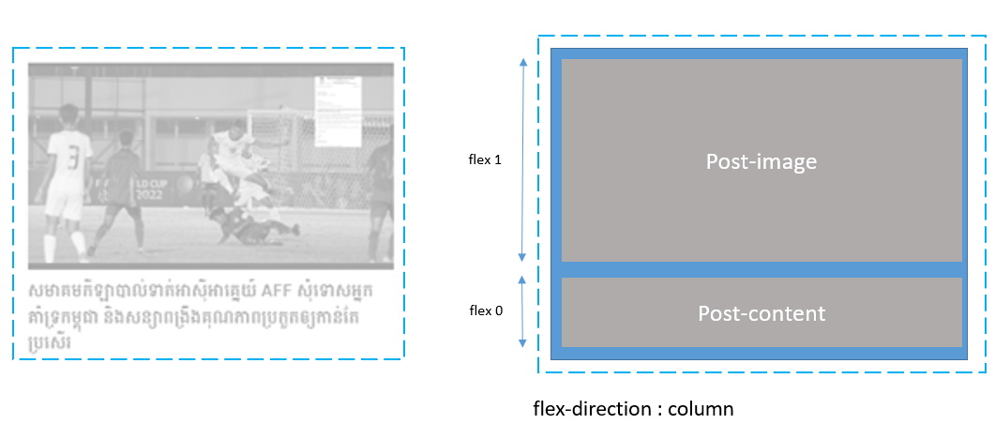

EXERCISE 1
Identify the needed flex containers to implement the bellow mockup.
- Start with the top containers first, and then the deeper containers
- Use flexbox layout only
- Name each of your CSS container appropriately

Note
- No coding required for this exercise; we need you to reflect on your CSS flex containers

To start
- You can start from the given power point slides

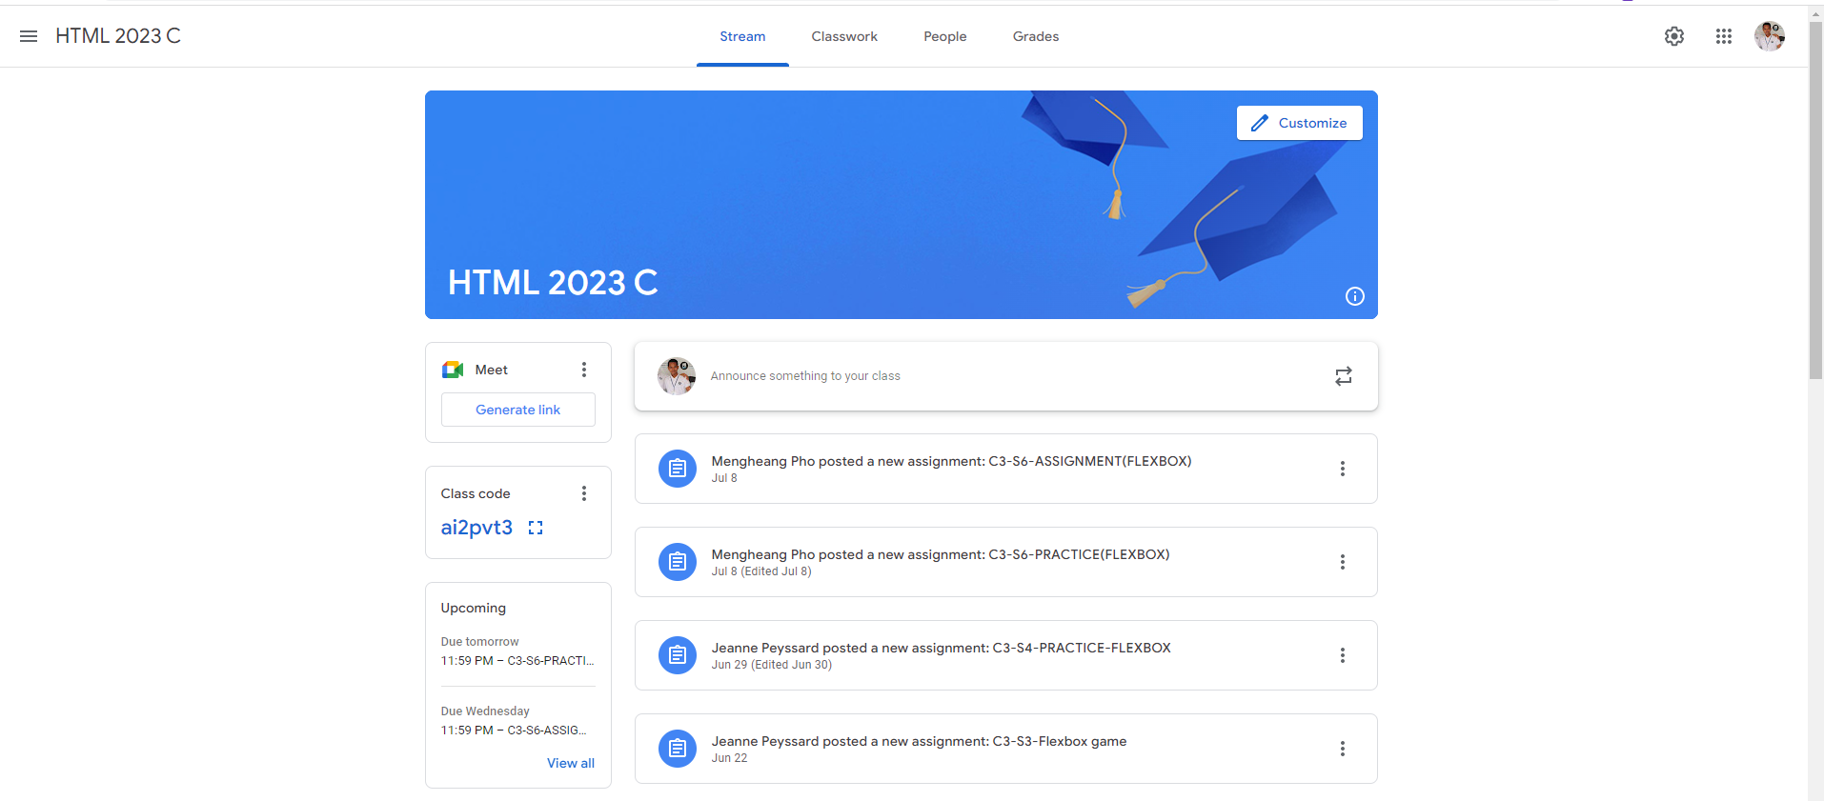

EXERCISE 2
You need to update an existing code to comply with the below mock up
- Use flexbox layout only

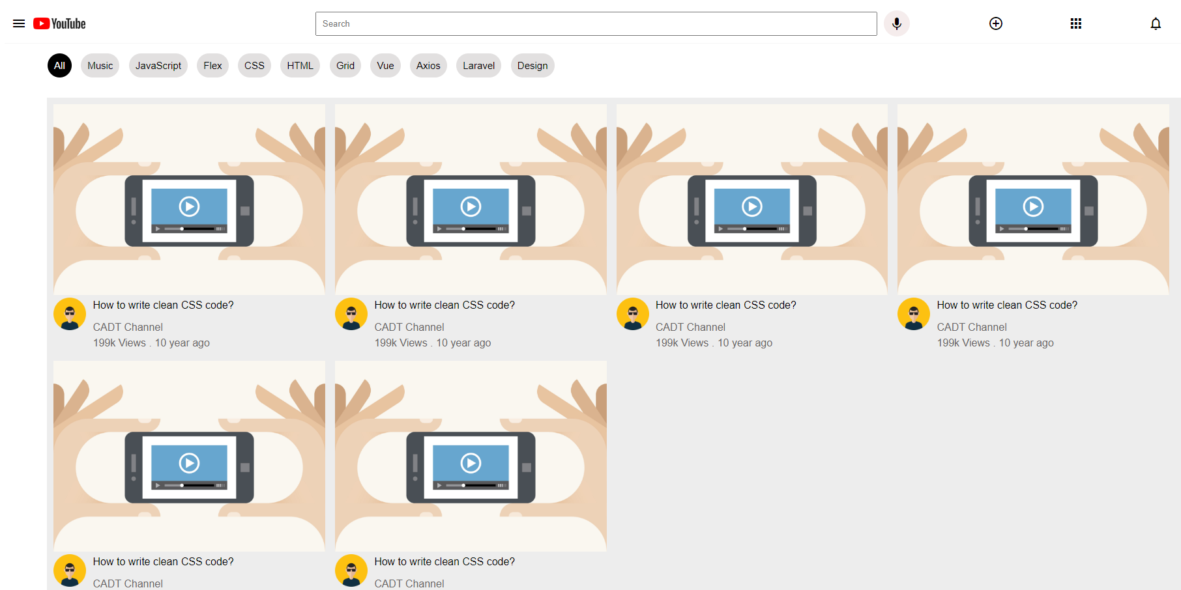

Hints
Before starting to code, identify your needed flex containers to match with the mockup

To start
- You start from the given code
- Nothing to change on the HTML code
- You only need to complete the CSS with Flex rules, on every TODO section

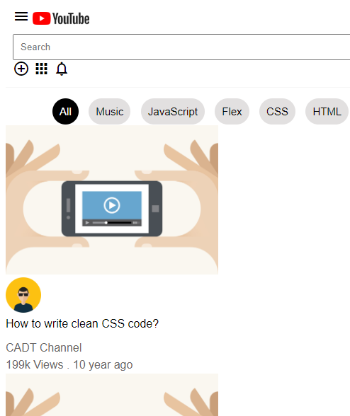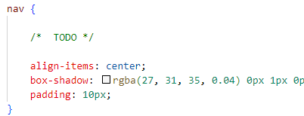

Just complete the CSSS with missing CSS rules

EXERCISE 3
We're going to use everything we learned about Flexbox to build a pricing table.
You've probably seen pricing table out on the Internet before.
It's usually three categories small, medium, large, and it shows the customers which features they'll get based on which tier they're going to subscribe to.

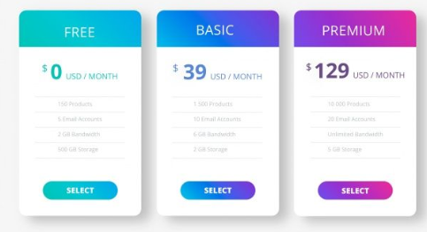

You need to build a pricing table with three items (Basic, Standard, Premium) using Flexbox.

Constraints
- Use must use flexbox to layout your page

- Make it responsive: when the window goes below a certain size(smartphone), it actually stacks the items vertically rather than having them horizontally.

- Be creative!! You can style it however you like!

Hints
Responsiveness works with media queries!
- what can you do, using media query and Flexbox attributes to achieve our needs?

To start
- You can start from the given index.html start code, or make you own

